

SCHOOL OF INFORMATICS & IT

Data Visualisation & Analytics
(CIA1C11)

DA Assignment

AY2025/2026 Apr Semester

Student Name (Matric Number) : Devananda Thayyullathil(2503060B)

Practical Group : PC04
Jenny LING (TP)
Tutor : Mr Poh Chai Chua

Submission Date : 31/07/2025

Declaration of Originality

I am the originator of this work and I have appropriately acknowledged all other original sources used as my references for this work.

I understand that Plagiarism is the act of taking and using the whole or any part of another person’s work, including work generated by AI, and presenting it as my own.

I understand that Plagiarism is an academic offence
and if I am found to have committed or abetted the offence of plagiarism in relation to this submitted work, disciplinary action will be enforced.

It’s Data Prep Time

1a. Data Profiling

In this dataset, there are 1500 rows of responses and 17 columns.

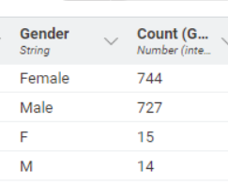 | In the gender column, there are inconsistent entries of values like “Female” and “F” representing the same category, and similarly, “Male” and “M”. From the occurrence table of the statistics node, we can see the number of times these inconsistent values are used. These inconsistencies can lead to incorrect analysis data.
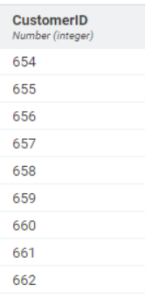 | The CustomerID column has the wrong data type. It should be a string data instead of a numeric value, since it represents IDs and we don’t use it for any calculations.
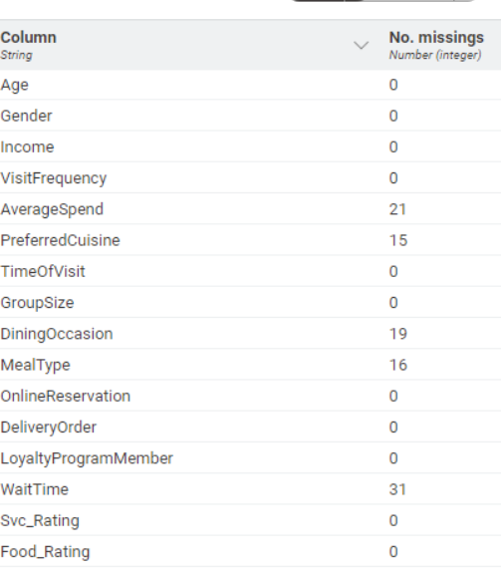 | Additionally, in the dataset, there are missing values present in the columns: AverageSpend, PreferredCuisine, DiningOccasion, MealType, and WaitTime.
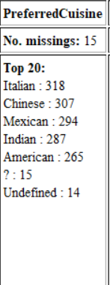 | In the column preferredCuisine, there is an invalid value “undefined”. It is a string value, but it represents null or missing values.
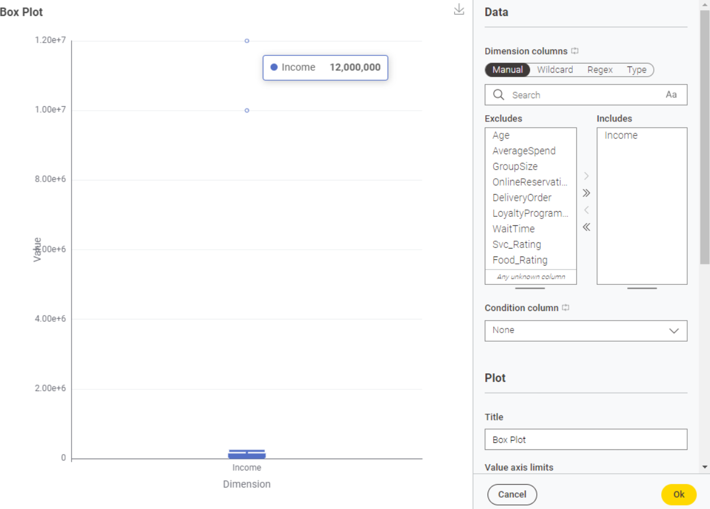 | Furthermore, the dataset contains outliers. For example, from the box plot of income, it is clear that there are extremely high values (1200000), while the median is around 85,917. These outliers can cause a significant difference when calculating the average, which can mislead the analysis.

1b. Data Cleaning

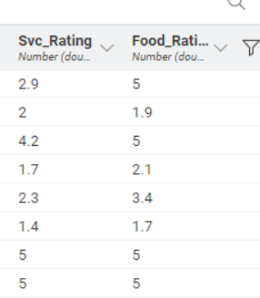 | 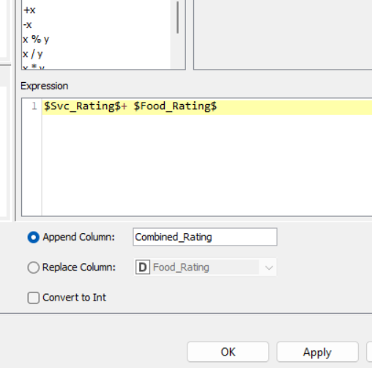 | 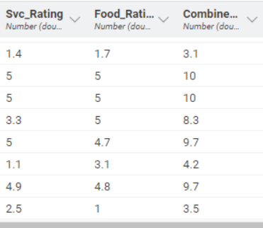
Before | Configuration | After

The math formula node is used to combine the Svc_Rating and Food_Rating. The sum of these two columns is then appended to the right side of the table as a new column called Combined_Rating.
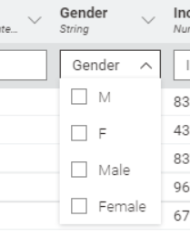 | 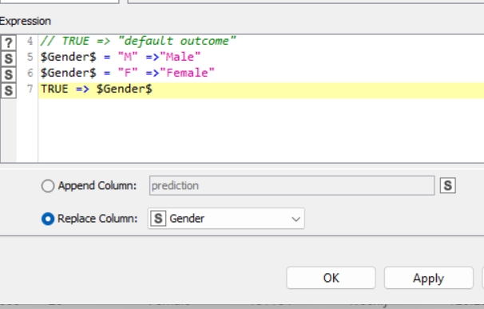 | 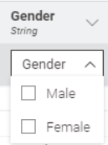
Before | Configuration | After

Next, to rectify the inconsistency in the gender, we use the Rule Engine node. I have set the string “M” to “Male” and “F” to “Female”. So, there won't be any more inconsistent values in the gender; only one value to represent a category.

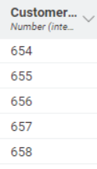 | 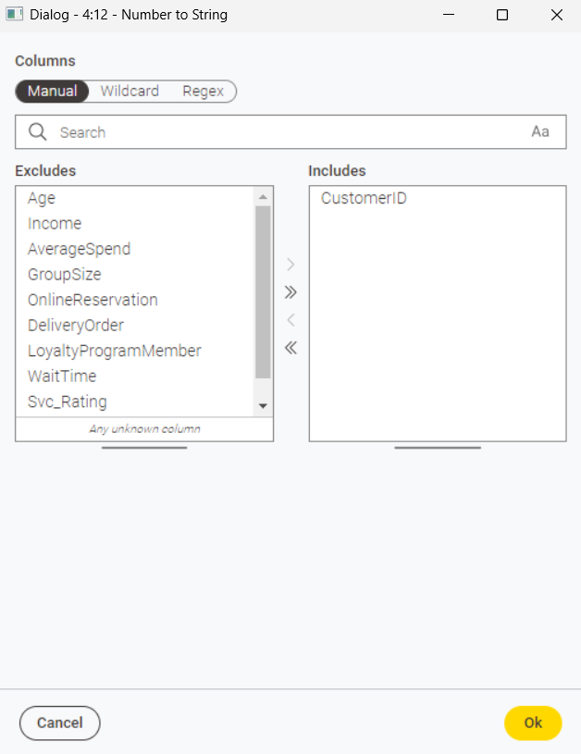 | 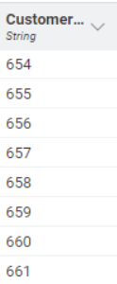
Before | Configuration | After

To change the data type of CustomerID from number to string, we use the Number to String node. In the configuration, we include the CustomerID and exclude everything else, so that the data type of the customer ID will be changed to String.
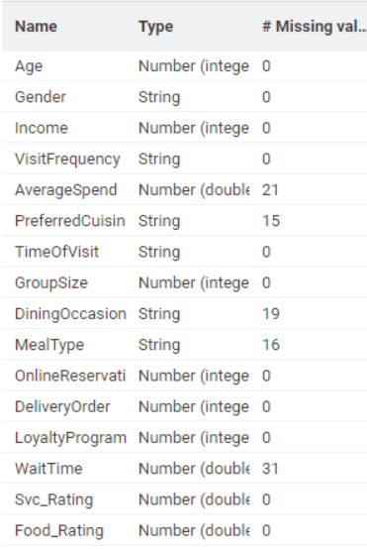 | 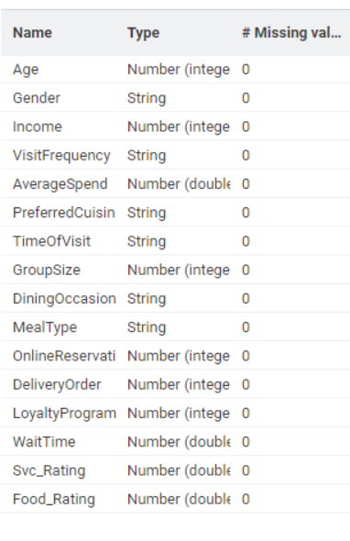
Before | After
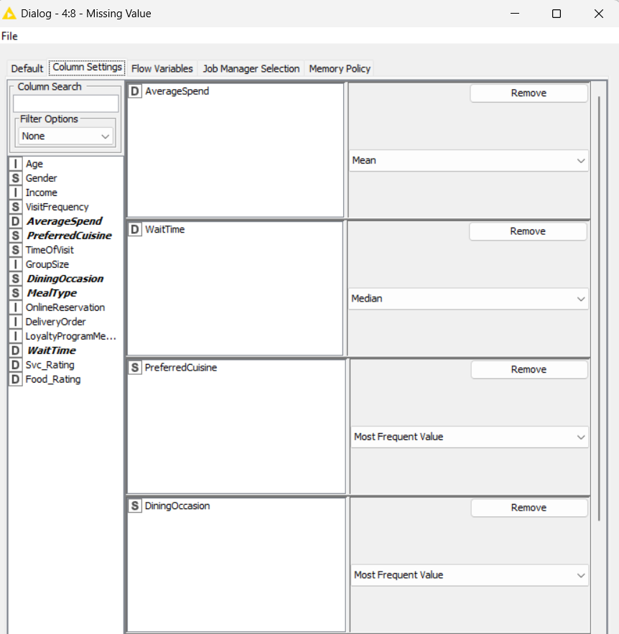 | 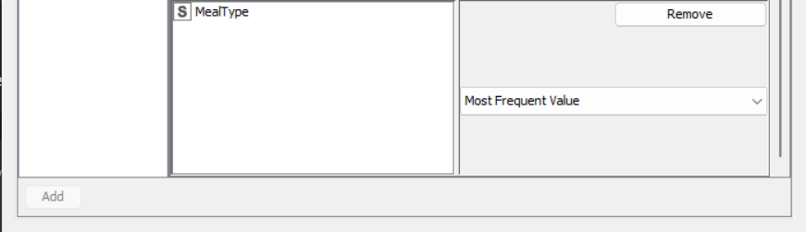
Configuration | Configuration
Next, the dataset contains missing values. So, for numeric values such as WaitTime, I used Median to replace the missing values because WaitTime contains outliers, so if we use the mean, the outcome will be inaccurate, hence I used median for WaitTime. Whereas, for AverageSpend I used the mean because its data is fairly consistent, and no outliers are present.
And for the categorical data, I have replaced the missing values with the most frequent Value(mode). The number of missing values is fractional compared to the whole dataset; hence, replacing it with the most frequent value won't affect the analysis
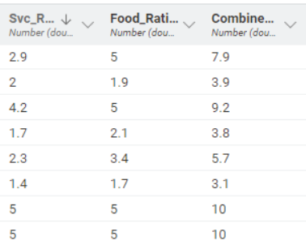 | 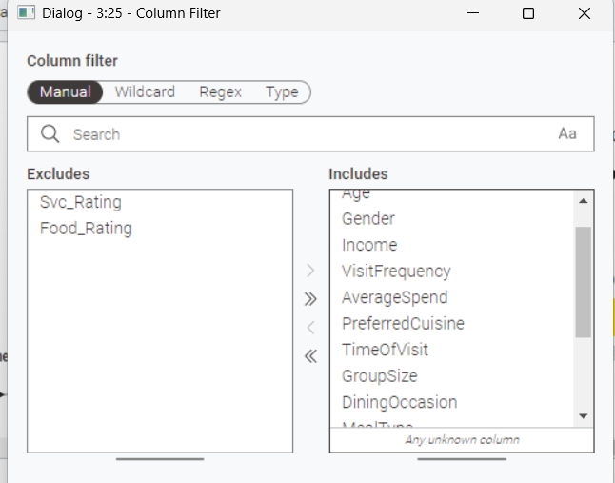 | 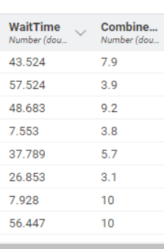
Before | Configuration | After

There are some unwanted columns in the dataset; the columns Svc_Rating and food_rating can be removed, as we already combined them to create a new column. These can be removed using the column filter node. Here, we exclude the unwanted columns and include the rest; as a result, we get a dataset with only the included columns.

1c. Other possible improvements

Some of the improvements are:

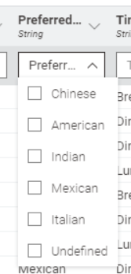 | 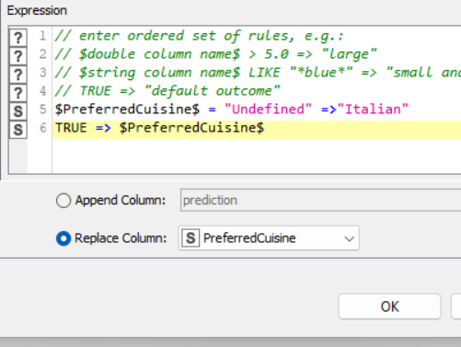 | 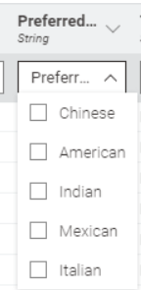
Before | Configuration | After

Here, the preferredCuisine column has an invalid value called” undefined” which can be considered as a null or missing value, so we can replace the undefined with the most frequent value, which is Italian, in the case of preferredCuisine. For this, we use a rule Engine and set the undefined value to Italian.
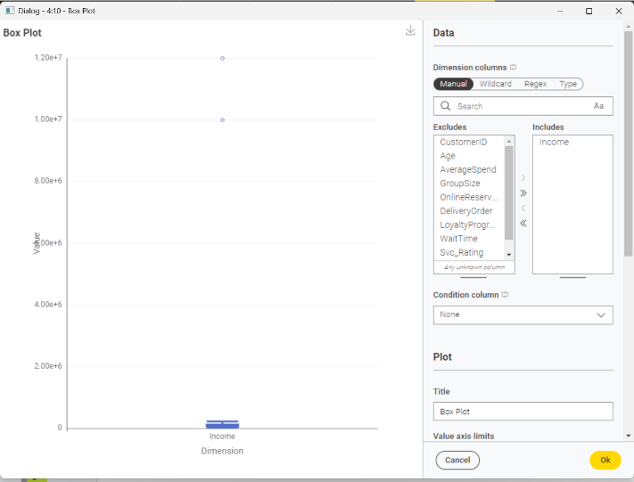 | 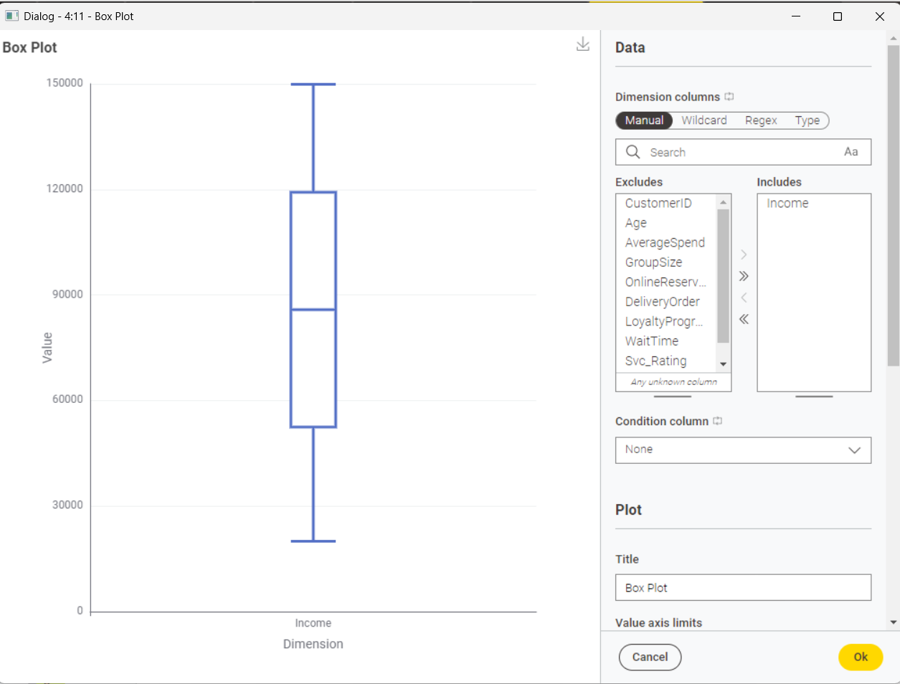
Before | After
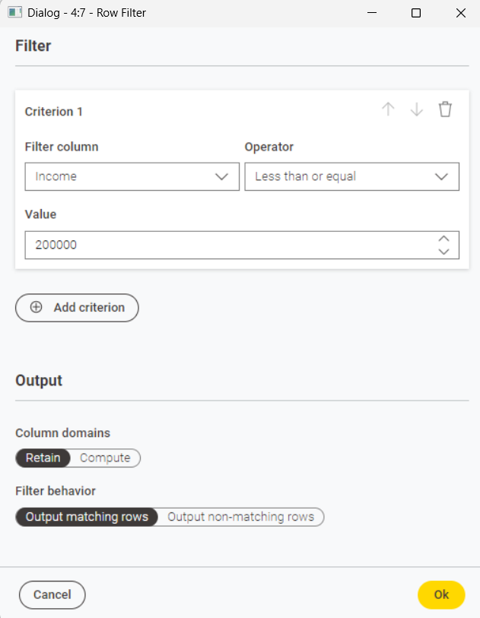
Configuration
Another improvement is to remove the outlier in the income column. The Extreme outliers can significantly affect the mean value, which then can affect the whole analysis. The mean is around 85,000, so approximately any value above 2,00,000 will be an outlier. We use a row filter to include only rows that are less than or equal to 2,00,000.

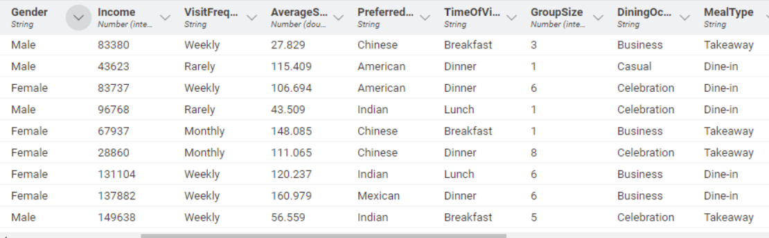
Before
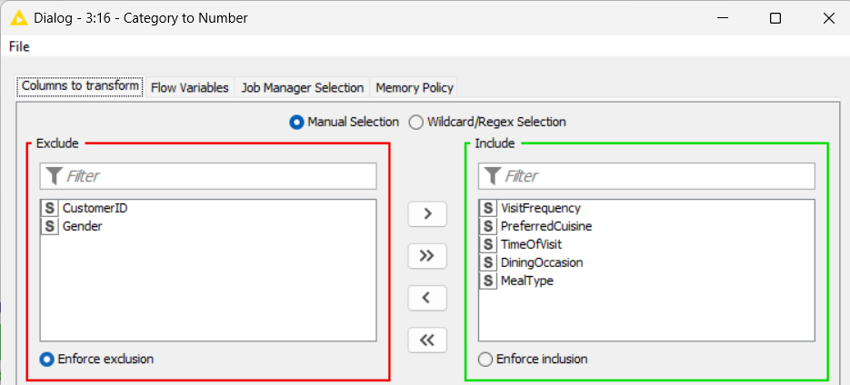
Configuration
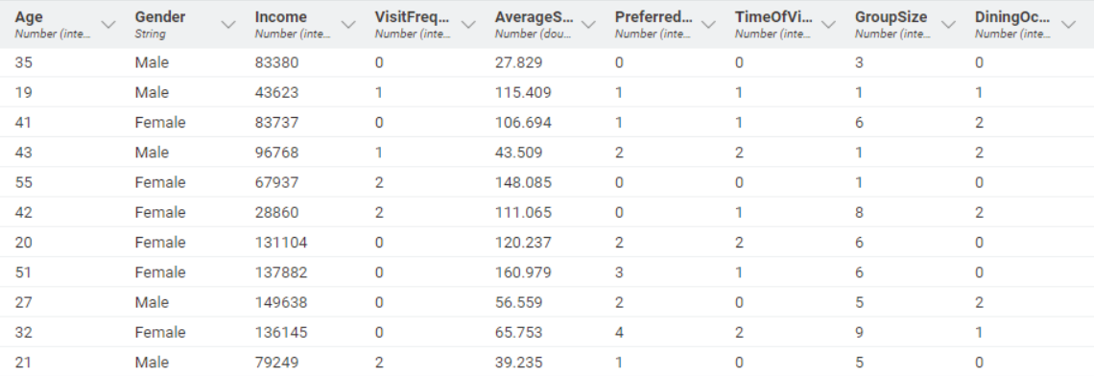
After

Lastly, if the data type of the columns that will be needed for further work in clustering or linear regression is string, then we change those to a numeric data type. For this conversion of data type, we use the Category to Number node. We convert the columns VisitFrequency, PreferredCuisine, TimeOfVisit, Dining Occasion, and MealType to numeric. Each value will be represented by a different integer number, for instance, in VisitFrequency, weekly is 0, rarely is 1, and monthly is 2. This can be useful for thorough analysis.

Clustering
2a. Steps taken:
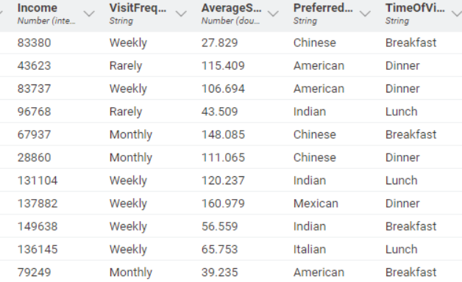 | 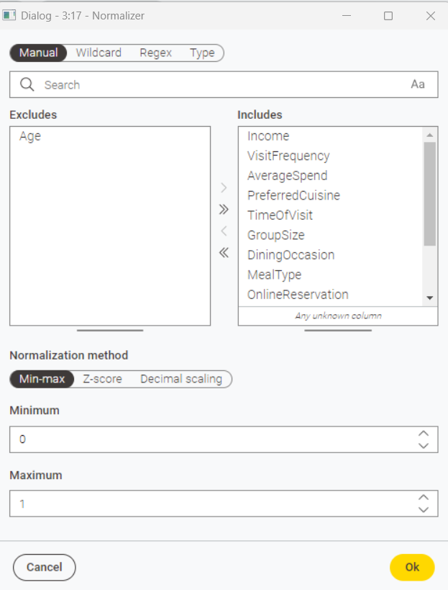 | 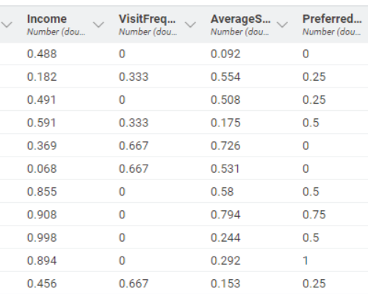
Before | Configuration | After

Firstly, for some columns, value ranges are so different from others, like for the income column, the range is from 20,000 to 1,50,000, while the range of AverageSpending is only around 10 to 200. Hence, we cannot use them, so we have to normalize these columns first. We use a normalizer node, with settings to use Min-Max Normalisation, with a minimum of 0.0 and a maximum of 1.0. Thus, we can convert all the data points to a number between 0 and 1.
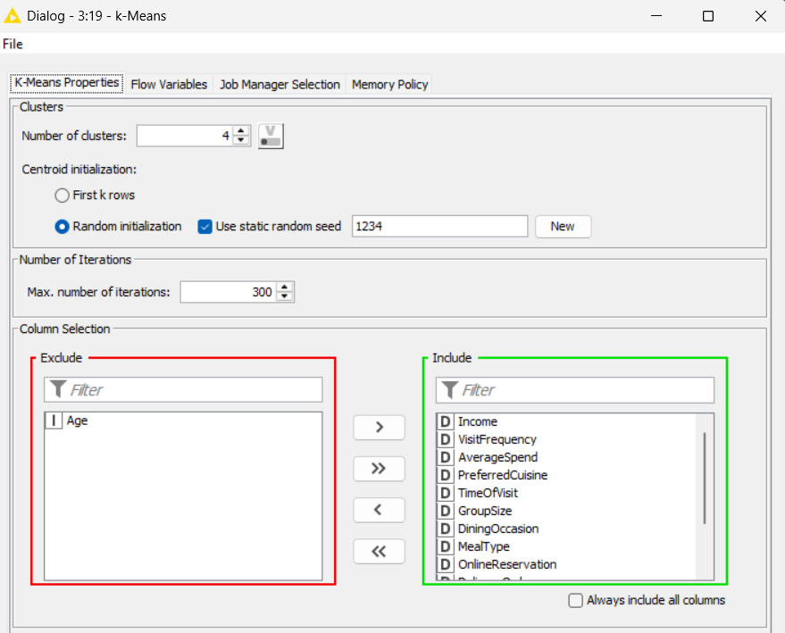 | 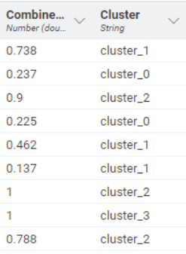
Configuration | After

Next, we use the K-Means node. We set the node to have 4 clusters, with a random initialization using random seed 1234. And the number of iterations is set to 300 to improve the accuracy, after 300 iterations, the algorithm quits if it has not found a way to cluster the data. I include all the numeric columns, excluding Age, since we want to find out the features that can be grouped roughly to Age. As a result of K-Means, we have a new column, Cluster, appended to the right of the table.
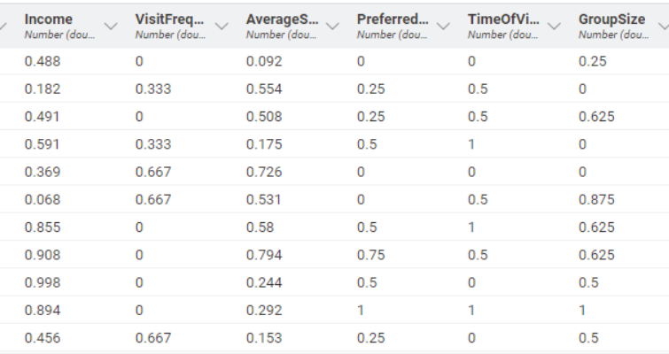 | Before denormalizer
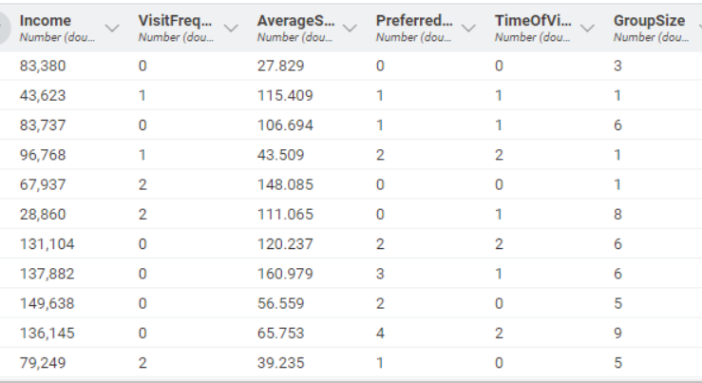 | After denormalizer
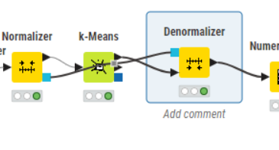

After that I use a denormalizer node to change the data back to their original values for example the income changes from 0.488 to its previous value 83,380. For this node there is no need for configuration.
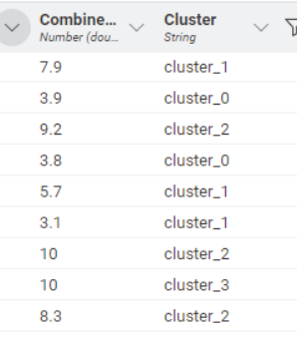 | 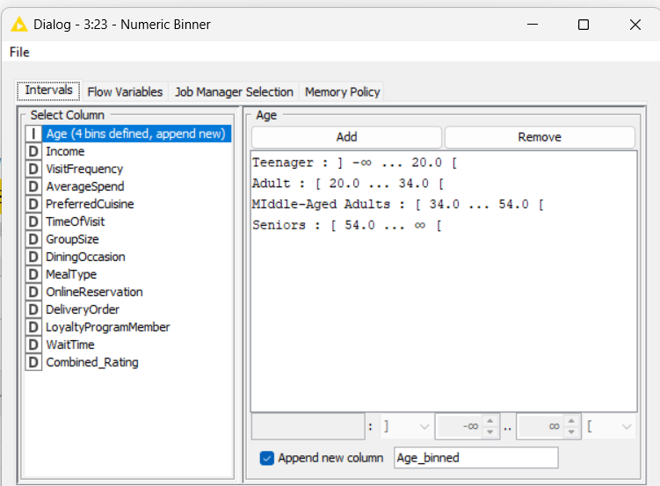 | 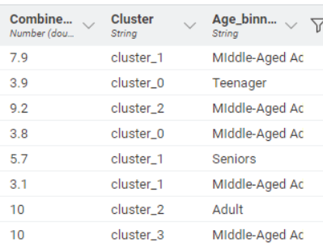
After | Configuration | After Binning

Finally, using a numeric Binner, the age column is binned into 4 bins. First bin with age negative infinity to 20 named Teenagers, second from 20 to 34 called Adult, third from 34 to 54 called Middle Aged Adults, and finally 54 and above labelled as Seniors. The bins are then appended to a new column called Age_binned to the right of the table.
Then we write this to a CSV file using the CSV writer node and ensure it contains the row ID for future use in Power BI.
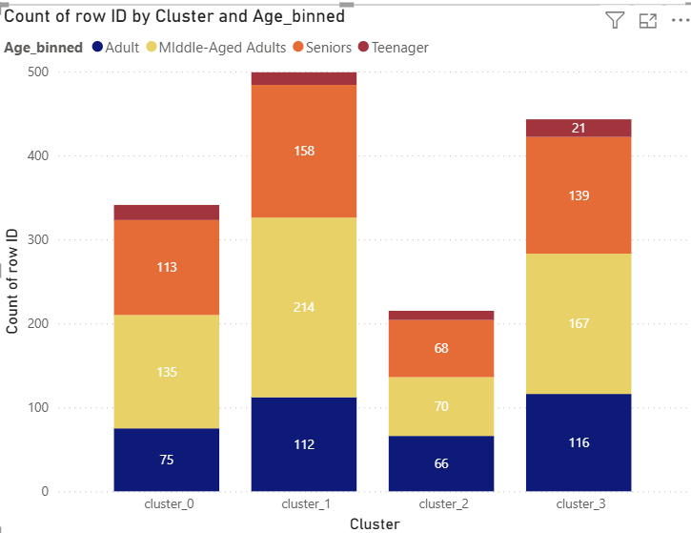
After we upload the earlier CSV file to Power BI for visual analysis. In the power Bl stacked column chart used to represent data, the x-axis represents the cluster, the y-axis represents the count of Row ID, and the legend as the Age_binned, and they are then sorted based on cluster in ascending order. From the above graph, in most clusters, the age groups are relatively evenly spread, indicating there is no strong dominance of an age group per cluster. For instance, in cluster 2, there are 66 Adults, 70 middle-aged adults, 68 seniors and 11 teenagers; there is no dominating value; they are mostly evenly distributed, hence we can say the clustering does not show a high degree of correlation with age.

2b. Findings / Explanation from Power BI:
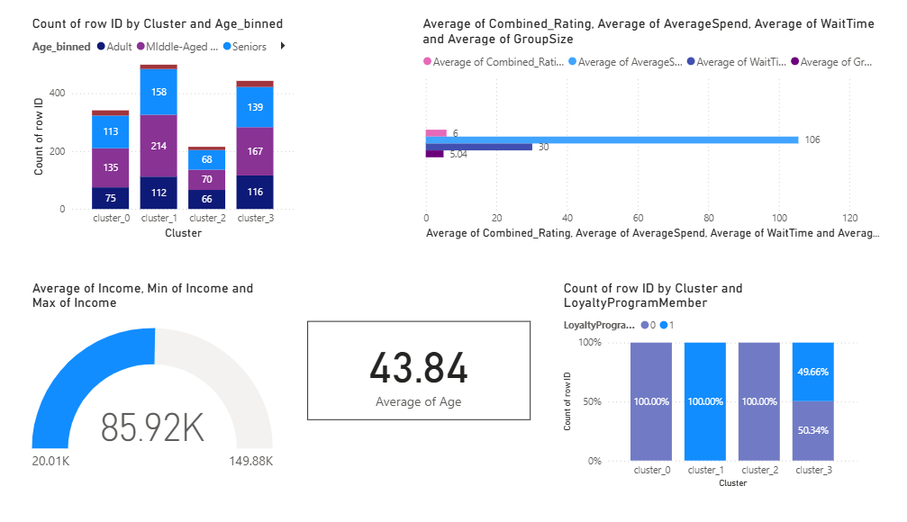
Above is a report created in Power BI.
- In the top left, there is a stacked column graph, which shows the relation between the cluster and the age_binned.
- In the top right, there is a clustered bar chart, which shows the averages of the Combined rating, Average spend, wait time and group size. These are used to summarise the behavioural pattern of each cluster
- In the bottom left, there is a gauge chart. It shows the average of the income, the range of the minimum and maximum income. When using a filter, it helps to understand the average income a cluster.
- In the bottom middle, is a card showing the Average Age of the entire dataset, or when we use a filter, it helps to find the average age of each cluster.
- In the bottom right, is the column chart of loyalty program participation, when filtered it help us to understand the engagement level of each clusters
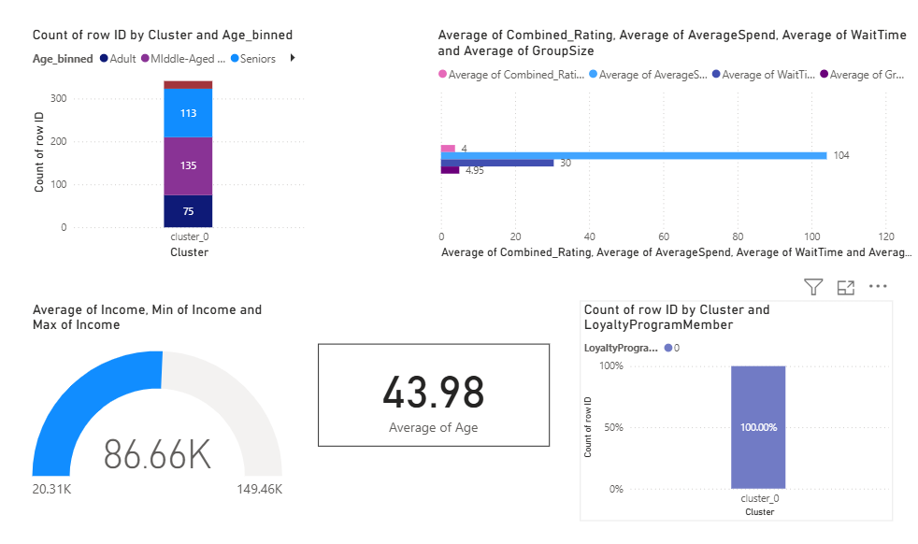
Above are the details about the cluster_0, most of the customers are middle-aged adults(135) and seniors(113), the average age being 43.98. The average of the combined rating is 4, the averagespending is 104, the waitTime is 30, and the groupsize is 4.95. The average income of this cluster is 86.66K. Customers of this cluster are not a part of the loyalty program(100% of the graph is value 0, which indicates not a member of the loyalty program).
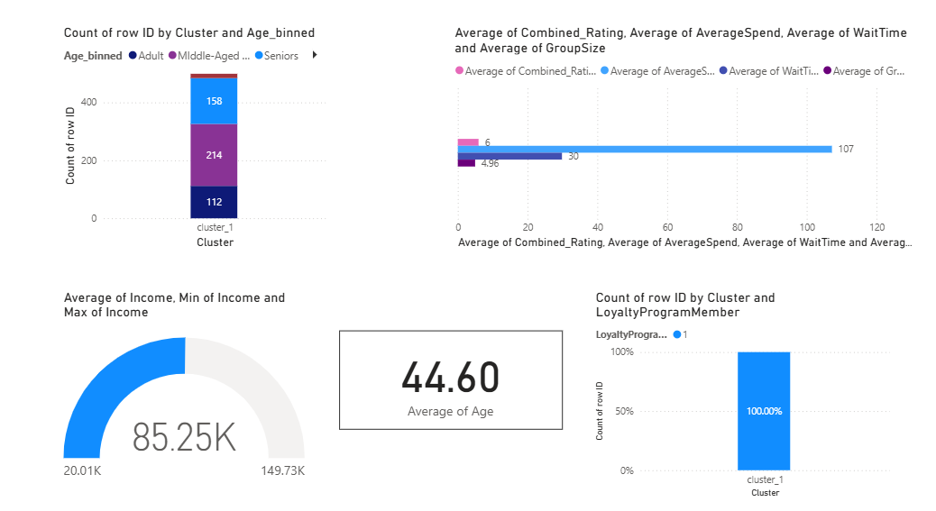
Above are the details about cluster_1; most of the customers are middle-aged adults(214) and seniors(158), the average age being 44.60. The average of the combined rating is 6, the averagespending is 107, the waitTime is 30, and the groupsize is 4.96. The average income of this cluster is 85.25K. Customers of this cluster are a part of the loyalty program(100% of the graph is value 1, which indicates a member of the loyalty program).
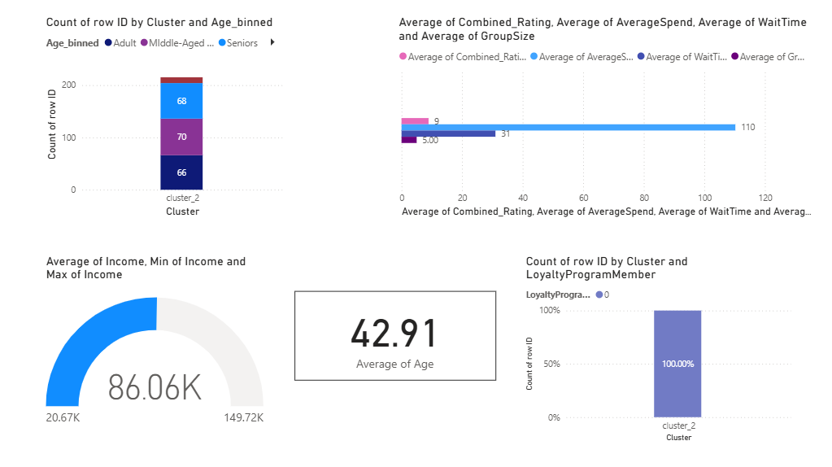
Above are the details about cluster_2; in this, the age distribution is almost equal, there are 66 Adults, 70 middle-aged adults, 68 seniors, and 11 teenagers, the average age being 42.91, which is lower compared to all other clusters. The average of the combined rating is 9, the averagespending is 110, the waitTime is 31, and the groupsize is 5.00. The average income of this cluster is 86.06K. Customers of this cluster are not a part of the loyalty program(100% of the graph is value 0, which indicates they are not members of the loyalty program).
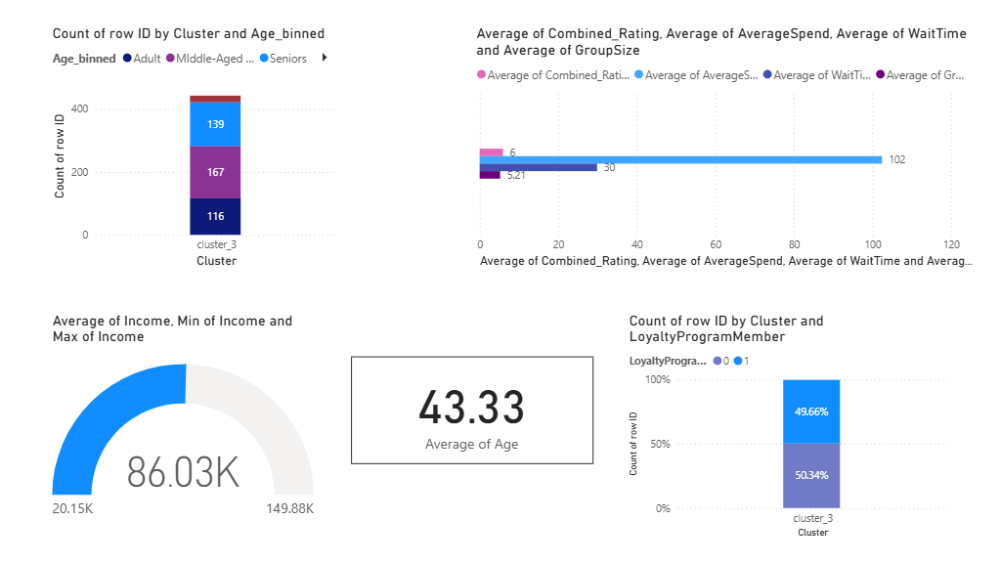
Above are the details about cluster_3; most of the customers are middle-aged adults(167) and seniors(116), the average age being 43.33. The average of the combined rating is 6, the averagespending is 102, the waitTime is 30, and the groupsize is 5.21. The average income of this cluster is 86.03K. Around half of the customers of this cluster are a part of the loyalty program(49.66% of the graph is value 1, which indicates a member of the loyalty program), and the others are not members of the loyalty program(50.34% of the graph is value 0, which indicates they are not members of the loyalty program).
When comparing the clusters in cluster_1 has the largest number of customers (480) and, the cluster_2 has the lowest number of customers(200). And cluster_2 has the most even distribution of ages(66, 70, 68). The average income of all the clusters is almost the same, it is around 86K.Cluster 2 has the lowest average age(42.91).
Neither customers of cluster_0 nor cluster_2 are members of the loyalty program, but all the customers of cluster_1 are members, and around half of the customers of cluster_3 are members, and the other half are not members of the loyalty program.
The average of the combined rating, the averagespending , the waitTime , and the groupsize is almost the same for all the clusters, it is around 4, 104, 30, 5, respectively.
Based on the data, we can say that the customers of cluster_0 and cluster_2 can be classified as non-loyal customers who have no loyalty membership but maintain engagement. But cluster_1 is a fully loyal cluster; 100% of customers have loyalty membership. Whereas cluster_3 is half and half. Despite this, every customer is treated equally.

Linear Regression

3a. Steps taken
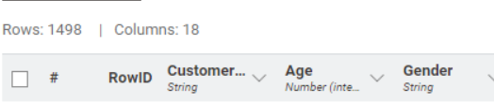 | 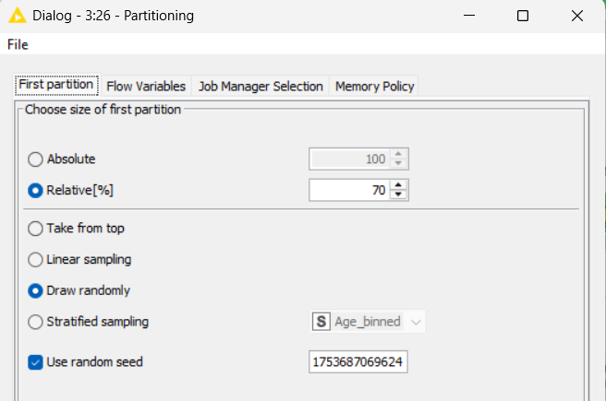
Before
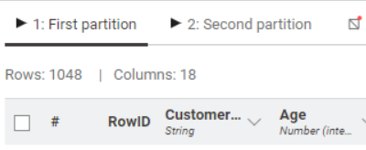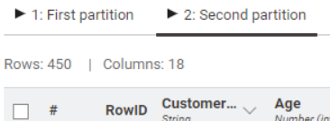
After
 | configuration
Firstly, the dataset is partitioned into 70% training data and 30% testing data using a partition node. Data is partitioned to estimate the model's performance on unseen data. The model learns from the training and is then tested on unseen data. In node configuration, we set the relative to 70% so the data will be split into 70% and 30% and set a random seed. As a result, we get two datasets of 1048 rows of training data and 450 rows of testing data.

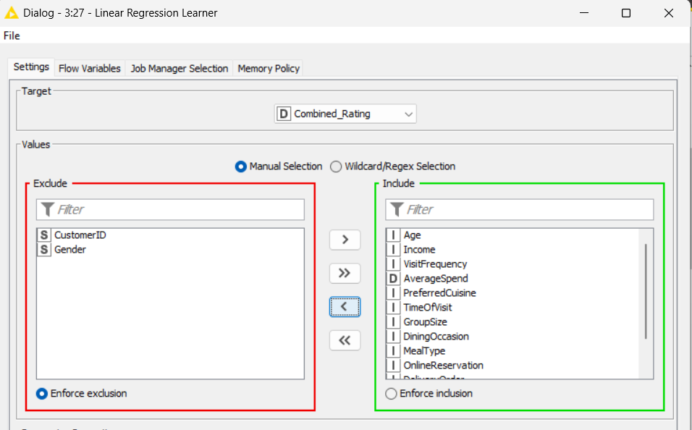 | configuration
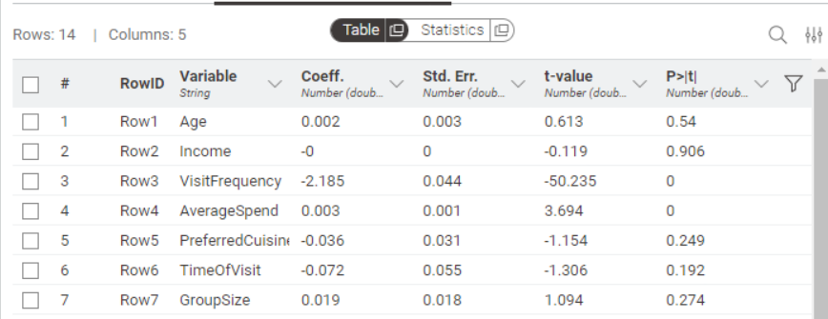 | After

Next, we use the 70 % training data for linear regression using the Linear Regression Learner node. Initially, all the columns are included, excluding all the columns with a data type of string. As a result, we get a table showing its coefficient and p-value. The P-value would indicate the predictive importance of the column. A P-value of less than 0.05 is generally considered a meaningful addition, so any column with a p-value higher than 0.05 is then removed.
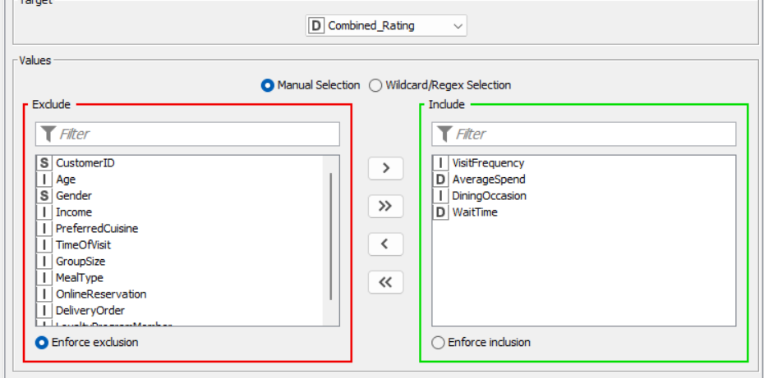
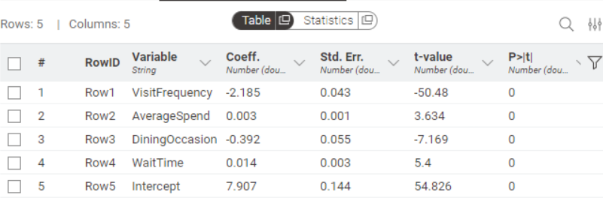
Next, we use the linear regression node again, but this time I excluded all the columns with a p-value higher than 0.05, and as a result, the table only has features with a p-value lower than 0.05.
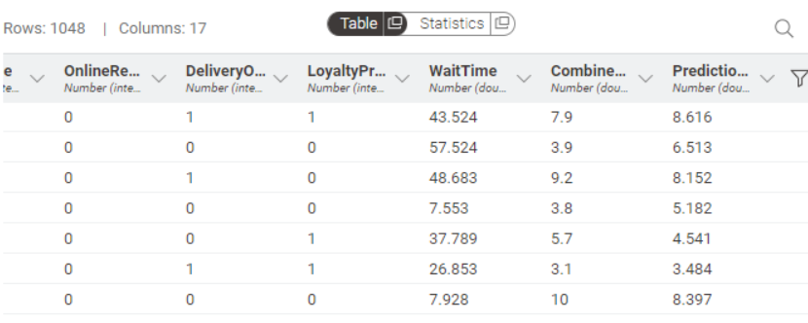
Next, a regression Predictor is added to the linear regression, and the training data (1048 rows) is given. As a result, a new column prediction combined rating is appended to the right of the table.
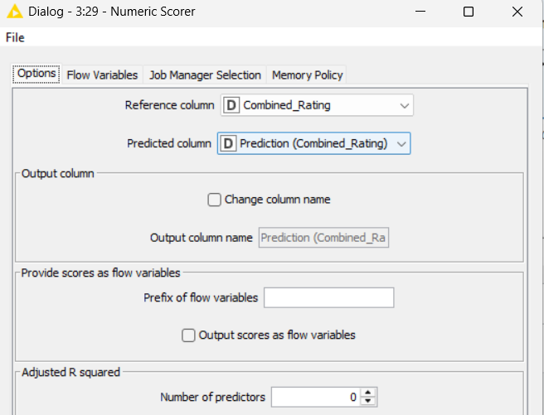 | 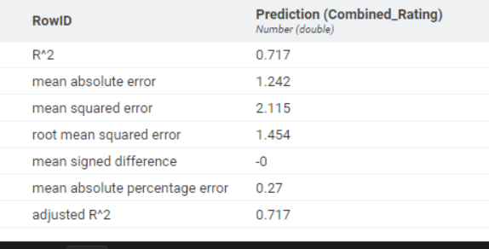
After that, we add a numeric scorer node to calculate the $R^{2}$ and RMSE values, it summarizes the quality of the regression model. The $R^{2}$ value is 0.717, which means the model explains 71.7% of the variability of the response data around its mean. And the RMSE is 1.454, which is a very low value, meaning the predicted value is only 1.454 away from the actual value.
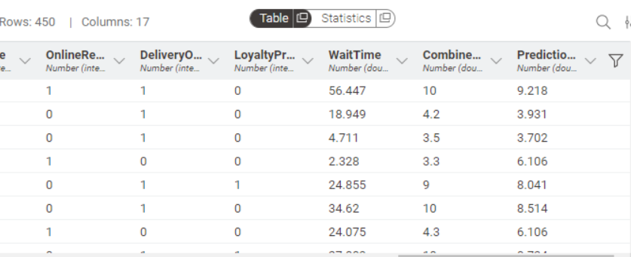
Next, a regression Predictor is added to the linear regression, and the testing data (450 rows) is given. As a result, a new column prediction combined rating is appended to the right of the table.

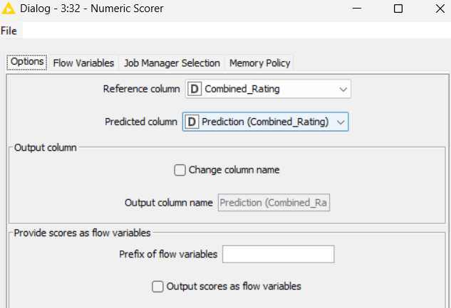 | 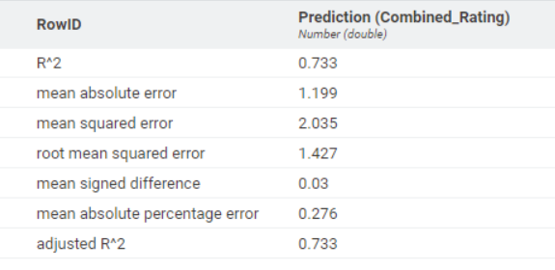
configuration | results
After that, we add a numeric scorer node to calculate the $R^{2}$ and RMSE values, it summarizes the quality of the regression model. The $R^{2}$ value is 0.733, which means the model explains 73.3% of the variability of the response data around its mean. And the RMSE is 1.427, which is a very low value, meaning the predicted value is only 1.427 away from the actual value.

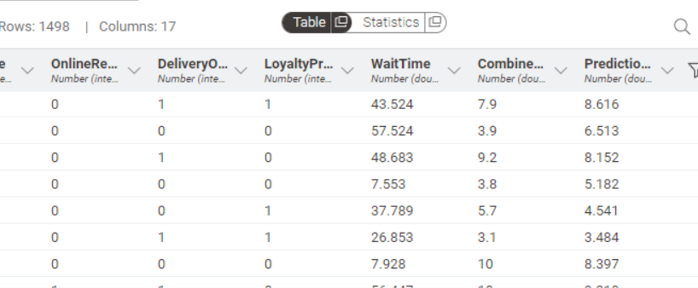
After that, a regression Predictor is added to the linear regression, and the whole dataset (1498). As a result, a new column prediction combined rating is appended to the right of the table. Which is then connected to a CSV writer.
The important features that can predict the combined rating are VisitFrequency, AverageSpend, DiningOccasion, and WaitTime. Their p-values are 0, which means they can significantly affect the prediction.
The equation is
Predicted Combined_Rating = -2.185 (VisitFrequency) + 0.003(AverageSpend) -0.392(DiningOccasion) + 0.014 (WaitTime) + 7.907

3b. Findings / Explanation from Power BI:

Using the numeric scorer, we find the $R^{2}$ is 0.717, which means the model explains 73.3% of the variability of the response data around its mean. This means ¾ times the prediction is true.

The Mean Absolute Error (MAE) is 1.242, the average of the absolute differences between predicted and actual values. Therefore, on average, the predictions are off by around 1.242 from the actual rating.

The Mean Squared Error (MSE) is 2.115, the average of the squares of the errors.

The Root Mean Squared Error(RMSE) is 1.454, which means on average, the model’s predictions are 1.454 away from the actual rating.

The Mean Significant Difference is -0, which means the system shows unbiased prediction; it doesn’t overpredict or underpredict the rating.

The Mean Absolute Percentage Error is 0.27, it means the predictions are within 27% of the actual values.
Overall, the model has good accuracy as the $R^{2}$ is 0.717, which is more than half, and the RMSE, is very low, only around 1.454, and Mean Signed Difference is 0, this shows the model doesn’t over-predict or under-predict.

Next, the CSV file from Knime is loaded into Power bl, in the table view, I add a new column called “Residuals”. The residuals column is the difference between the actual combined rating and the predicted combined rating

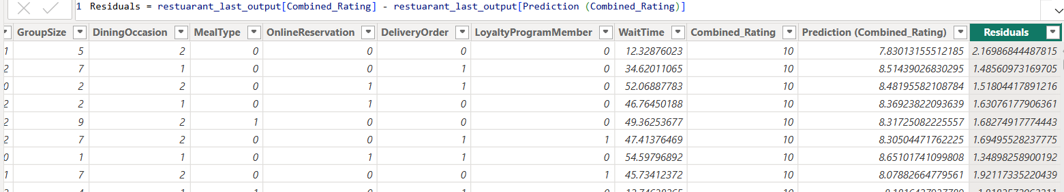

- Is the model a good fit for the data? Use Power BI to analyse the residuals. Provide relevant screenshots to support your justification.
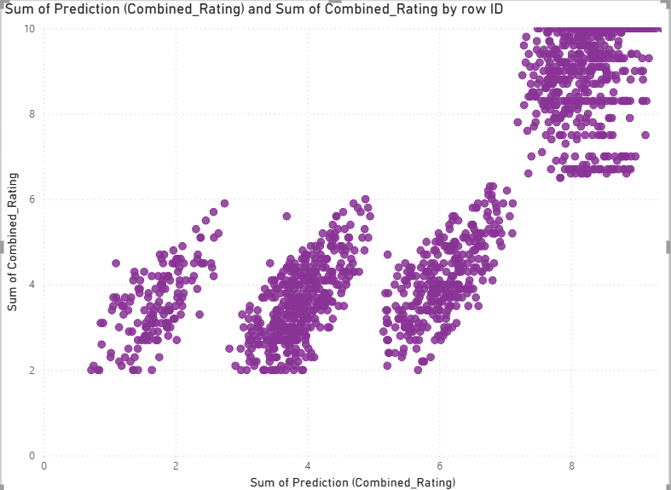
After that, a scatter plot is used, the x-axis represents the predicted combined values, the y-axis represents the actual combined rating, and the values are the rowID. It shows how much the predicted values differ from the actual values. The data points form different clusters, which follow a diagonal upward trend showing positive correlation, but the points are not aligned with the x=y line, indicating prediction error.
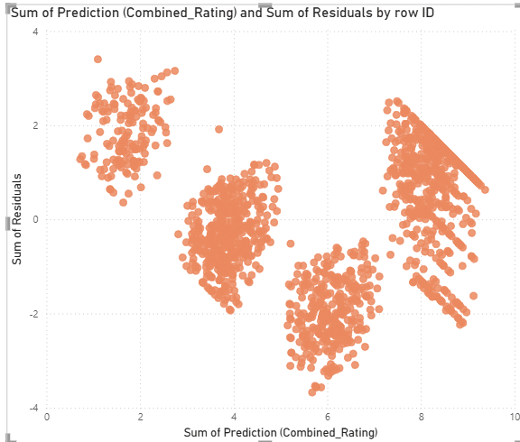
In this scatter plot, x-axis is the sum of the prediction combined rating, the y-axis is the residuals, and the value is rowID. Residual is the error in the prediction. The residuals are spread fairly even above and below zero, cancelling each other, indicating the model does not have a consistent bias, that is, it is neither over-predicting nor under-predicting.
The model is generally unbiased and performs reasonably well with moderate accuracy.

Screenshot of my overall KNIME workflow is shown below.

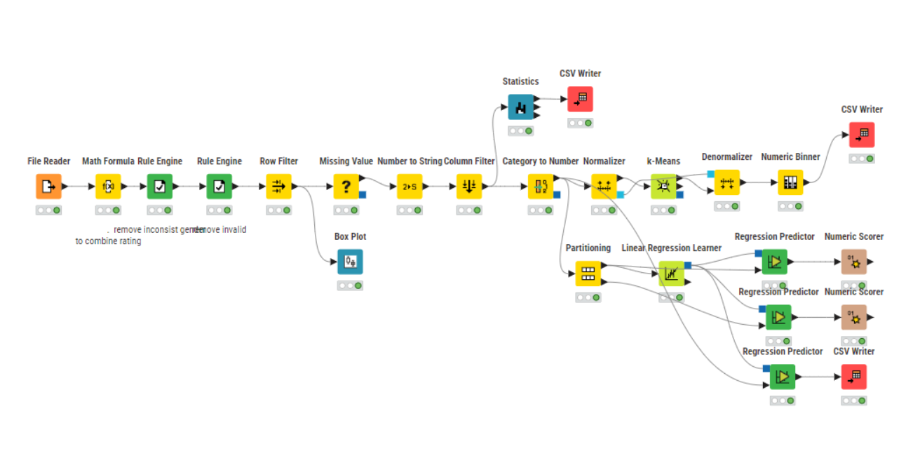

SUBMISSION INSTRUCTIONS

- Save this file as “DA_Assignment_[Your Class]_[Your Full Name]_[Your Student ID]”,
e.g. “DA_Assignment _P01_ALBERT EINSTEIN_2509999A”.
- Export your KNIME workflow [In KNIME, select File -> Export KNIME Workflow - > Enter the destination file path and name -> Finish]
- Submit your report, together with your KNIME (.knwf) and Power BI (.pbix) files, to DAVA LMS site > Assessment > DA Assignment > Look for the appropriate link to submit your work.

***** END OF DA ASSIGNMENT *****

